TradeWise: Stock Performance Analysis

Submitted By: Chandni Kalchuri

Objective Questions:

- Analysis and Insights: Visualize the backtesting results using charts:
  - Total returns for top 20 stocks over time.
  - Cumulative returns over time of the selected stocks (Taking first 5 stocks after sorting the data).
  - Sharpe ratio vs. total return of first 20 stocks after sorting the data
Answer:
Part A: Total returns for top 20 stocks over time.

- Guideline: Analyze the historical trajectory of total returns across the top 20 Nifty 50 stocks to identify volatility and yearly performance trends.

- Visualization:
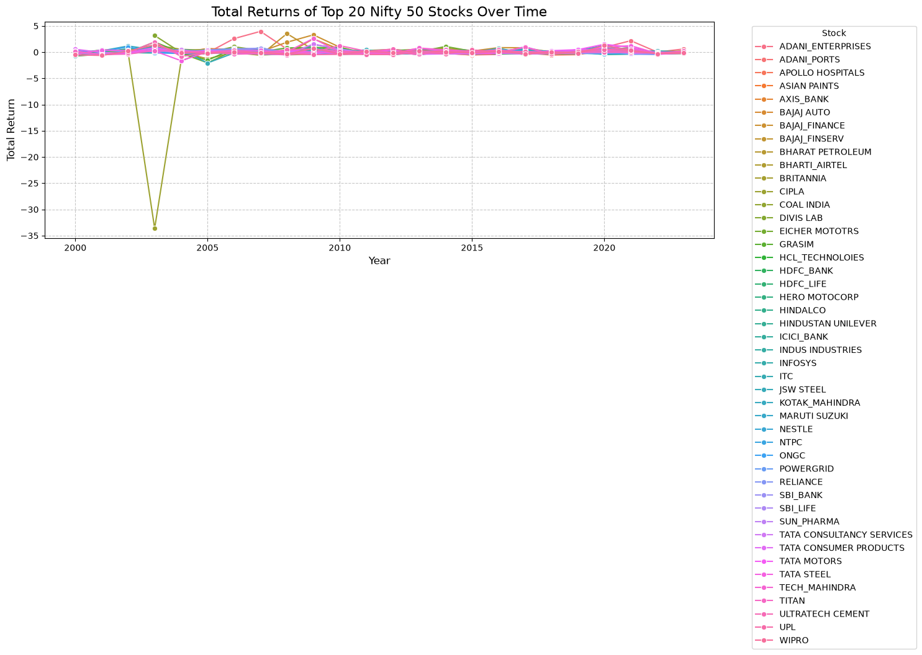

Figure 1: Line chart displaying the Total Returns of Top 20 Nifty 50 Stocks over time.

- Observation: The analysis reveals significant market volatility, with most stock returns fluctuating closely around the baseline. Noticeable extreme spikes and drawdowns (e.g., around the year 2003) indicate periods of high market instability affecting specific assets.

PART B: Cumulative returns over time of the selected stocks (Taking first 5 stocks after sorting the data).
    - Guideline: Evaluate the long-term wealth compounding effect by tracking cumulative returns for the first 5 alphabetically sorted stocks (ADANI_ENTERPRISES, ADANI_PORTS, APOLLO HOSPITALS, ASIAN PAINTS, AXIS_BANK).

    - Visualization:
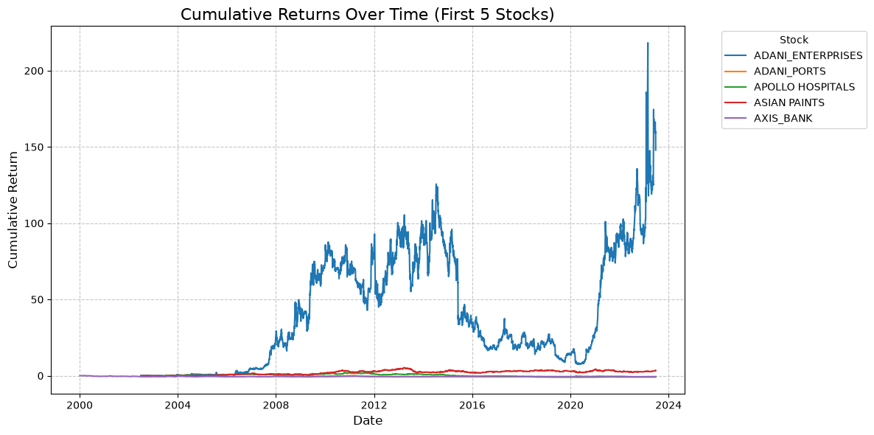

Figure 2: Line chart comparing the Cumulative Returns of the first 5 alphabetically sorted stocks.

- Observation: ADANI_ENTERPRISES demonstrates an exponential compounding effect over the analyzed period, significantly outperforming the other four stocks. The remaining stocks exhibit relatively flat or slow-growing trajectories, highlighting a massive disparity in long-term wealth generation.

PART C: Sharpe ratio vs. total return of first 20 stocks after sorting the data
- Guideline: Assess the risk-adjusted performance of the stocks by plotting their average Total Return against their average Sharpe Ratio to identify the most efficient investments.

- Visualization:

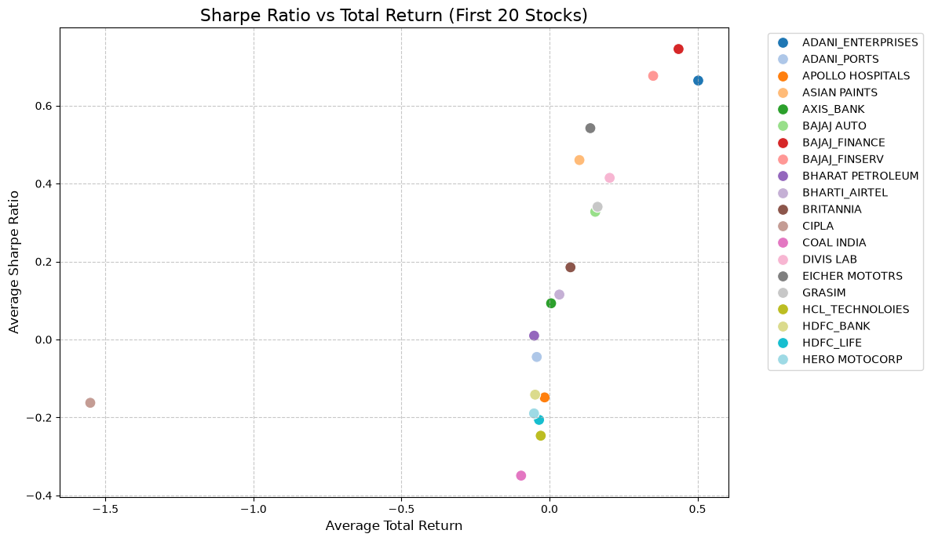

Figure 3: Scatter plot illustrating the relationship between Sharpe Ratio and Total Return.

    - Observation: A strong positive correlation is observed between the Sharpe Ratio and Total Return. Stocks positioned in the top-right quadrant (e.g., BAJAJ_FINANCE and ADANI_ENTERPRISES) offer the most efficient risk-adjusted returns, successfully maximizing profitability relative to the risk taken.

- Generate a pair plot of selected performance metrics (total return, Sharpe ratio, max drawdown) for the stocks. What insights can you derive from the relationships between these metrics?
Answer:
- Guideline: Utilize a pair plot to visually analyze the pairwise relationships and distributions among Total Return, Sharpe Ratio, and Maximum Drawdown to uncover underlying risk-reward dynamics.

- Visualization:

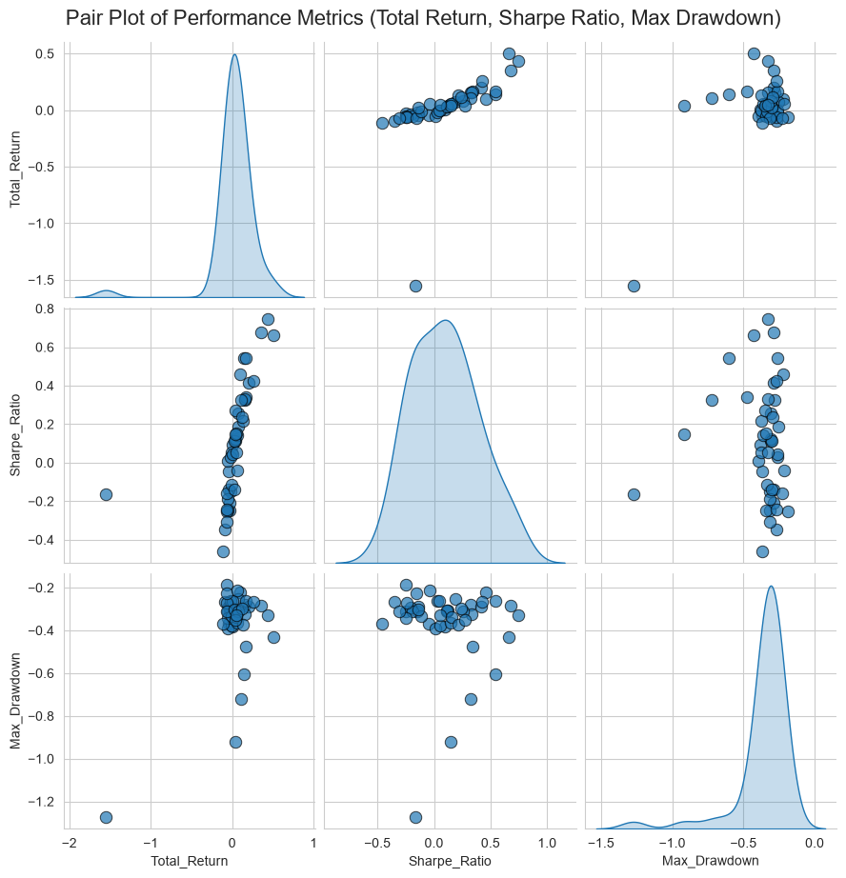

Figure 4: Pair plot displaying the distributions and relationships between Total Return, Sharpe Ratio, and Max Drawdown.

- Insights & Data Justification:
- Insight 1 (Total Return vs. Sharpe Ratio): The scatter plot reveals a distinct positive correlation. As Total Returns increase, the Sharpe Ratio generally improves.
  - Justification: This implies that higher-returning stocks are often achieving those returns efficiently without disproportionate volatility.
- Insight 2 (Total Return vs. Max Drawdown): There is a nuanced relationship where stocks capable of extreme high returns also occasionally exhibit severe maximum drawdowns (points scattered lower on the y-axis).
  - Justification: This highlights the classic risk-reward tradeoff; pursuing aggressive growth often exposes the portfolio to deeper historical losses.
- Insight 3 (Sharpe Ratio vs. Max Drawdown): A positive trend exists where stocks with robust (higher) Sharpe Ratios tend to have less severe (closer to zero) maximum drawdowns.
  - Justification: This confirms that superior risk-adjusted performance (Sharpe Ratio) serves as a reliable indicator of historical capital preservation (lower Drawdown) during market downturns.

- Which stock has shown the highest total return over the analyzed period?
Answer:
- ADANI_ENTERPRISES achieved the highest average total return (0.50).
- Observation: This indicates that ADANI_ENTERPRISES was the most profitable asset among the analyzed group over the given timeframe, demonstrating superior long-term wealth generation potential.

- Which stock has the lowest maximum drawdown, indicating stability?
Answer:
- NESTLE recorded the lowest maximum drawdown at -0.19 (-19%).
- Observation: A drawdown of only 19% signifies exceptional price stability and capital preservation. NESTLE exhibits strong defensive characteristics, making it highly resilient during broader market downturns.

- What are the best and worst months for each stock in terms of returns?
Answer:
(Sample of the first 3 evaluated stocks)
  - ADANI_ENTERPRISES: Best Month = May (5), Worst Month = February (2)
  - ADANI_PORTS: Best Month = April (4), Worst Month = June (6)
  - APOLLO HOSPITALS: Best Month = November (11), Worst Month = March (3)

- Observation: Analyzing the monthly performance reveals distinct seasonal trends for individual stocks. This insight can be strategically leveraged to time market entries and exits for maximum efficiency.

- Which stocks have the highest average trading volume?
Answer:
    - TATA STEEL recorded the highest average trading volume (71,141,650 shares).
    - Observation: Consistently high trading volume indicates massive liquidity and strong market interest, ensuring that large orders can be executed without significantly impacting the stock price.

- What is the total number of trades executed for each stock?
Answer:
- Based on the Moving Average Crossover strategy, the total trades executed for the sample stocks are:
  - ADANI_ENTERPRISES: 124 trades
  - ADANI_PORTS: 99 trades
  - APOLLO HOSPITALS: 148 trades
- Observation: The number of trades reflects the frequency of moving average crossovers. A higher trade count (like Apollo Hospitals) suggests higher price volatility leading to frequent trend reversals.

- Which stock had the maximum single-day loss (highest negative daily return) during the analysis period?
Answer:
- BAJAJ_FINSERV experienced the maximum single-day loss of -92.65% on May 26, 2008.
- Observation: Such an extreme single-day drop is an anomaly, likely reflecting a major corporate action (such as a stock split or demerger) or a severe systemic market shock during the 2008 financial crisis.

- Which stock had the maximum single-day gain (highest positive daily return) during the analysis period?
Answer:
- CIPLA recorded the maximum single-day gain of 1,224.17% on November 27, 2003.
- Observation: A single-day gain of this magnitude is exceptionally rare and typically points to unadjusted historical data anomalies related to significant corporate restructuring, rather than standard market movement.

- Which stock had the lowest average closing price over the analysis period?
Answer:
- TATA STEEL had the lowest average closing price at 43.32.
- Observation: While having the lowest nominal share price, it is important to note that this does not indicate the company's valuation or market capitalization, but rather its absolute price level per share in the historical dataset.

Subjective Questions:

- How do the annualized returns compare across the top 20 stocks?
Answer:
- Guideline: Provide a comparative analysis of the annualized returns across the selected top 20 stocks to evaluate their long-term compounding performance.
- Visualization:
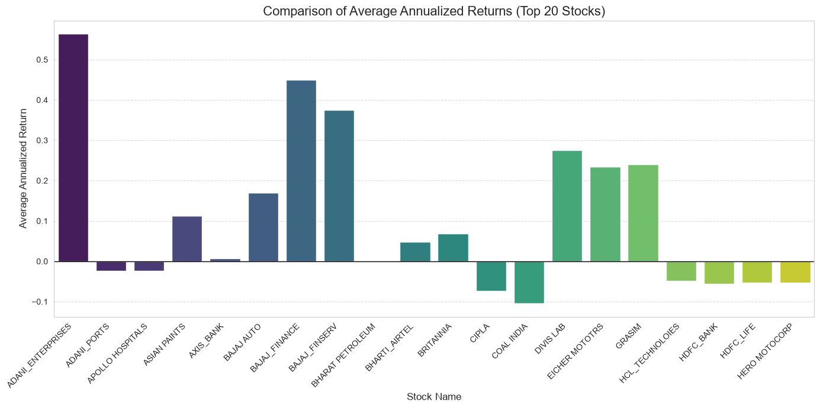
Figure 5: Bar chart comparing the average annualized returns of the top 20 Nifty 50 stocks.

- Insights:
- Performance Disparity: The bar chart reveals a significant disparity in annualized returns among the top 20 stocks. While a few stocks like ADANI_ENTERPRISES show exceptionally high positive annualized returns (indicating strong wealth compounding), others hover near zero or show negative returns (e.g., COAL INDIA).
- Sector Outperformance: The visual comparison helps quickly identify which specific assets consistently outperform the baseline average over the analyzed period.

- Recommendations:
- Investment Strategy: For long-term growth portfolios, prioritize allocating capital towards stocks demonstrating consistently high positive annualized returns, as they provide the best compounding effects over time.
- Portfolio Pruning: Re-evaluate or reduce exposure to stocks showing flat or negative annualized returns, as they act as a drag on overall portfolio growth and capital efficiency.

- What is the relationship between total return and trading volume for the stocks?
Answer:
- Guideline: Analyze if there is a discernible correlation between a stock's average trading volume (liquidity) and its average total return to understand if highly traded stocks inherently yield better returns.

- Visualization:
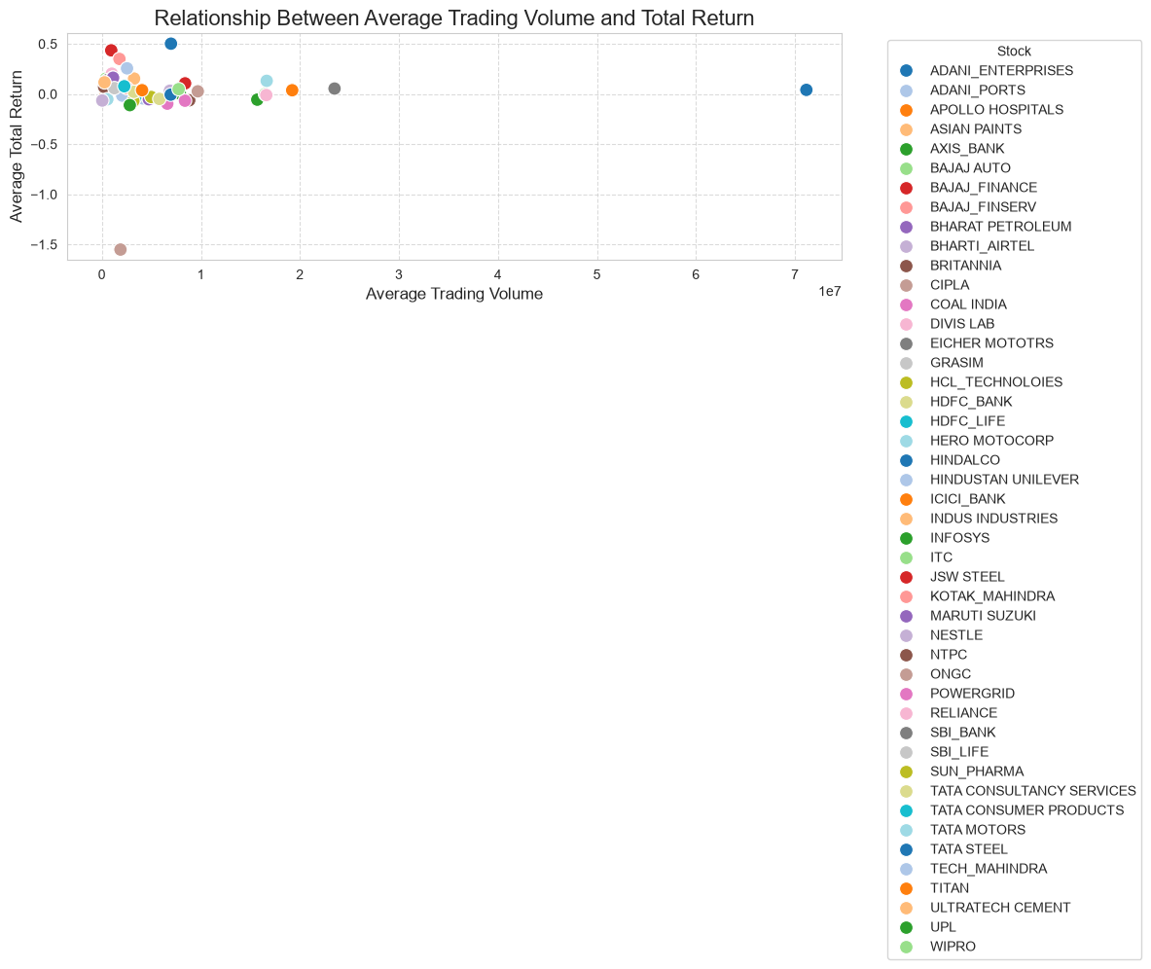
Figure 6: Scatter plot illustrating the relationship between Average Trading Volume and Average Total Return.

- Insights:
- Weak Correlation: The scatter plot indicates a very weak or non-existent direct correlation between trading volume and total return. Stocks with exceptionally high trading volumes (e.g., TATA STEEL, positioned far right) do not necessarily guarantee the highest total returns.
- Concentration of High Returns: Conversely, stocks that achieved the highest average returns (e.g., ADANI_ENTERPRISES) are clustered in the lower-to-mid volume range on the x-axis, suggesting that massive liquidity is not a prerequisite for high profitability.

- Recommendations:
- Volume as a Liquidity Metric, Not a Growth Indicator: Trading volume should be used primarily to assess a stock's liquidity (ease of entry and exit) rather than as a predictive indicator for future high returns. Do not select stocks solely based on high trading volumes expecting outsized gains.
- Balanced Screening: When formulating an investment strategy, use trading volume as a preliminary filter to ensure sufficient market liquidity, but rely on fundamental metrics and historical return/drawdown ratios (like the Sharpe Ratio) to identify actual growth potential.

- Generate a heatmap of the correlation matrix for the closing prices of the top 20 stocks. Which stocks are most correlated with each other?
Answer:
- Guideline: Create a correlation heatmap to analyze how the closing prices of the top 20 stocks move in relation to one another, identifying potential diversification opportunities or concentration risks.
- Visualization:
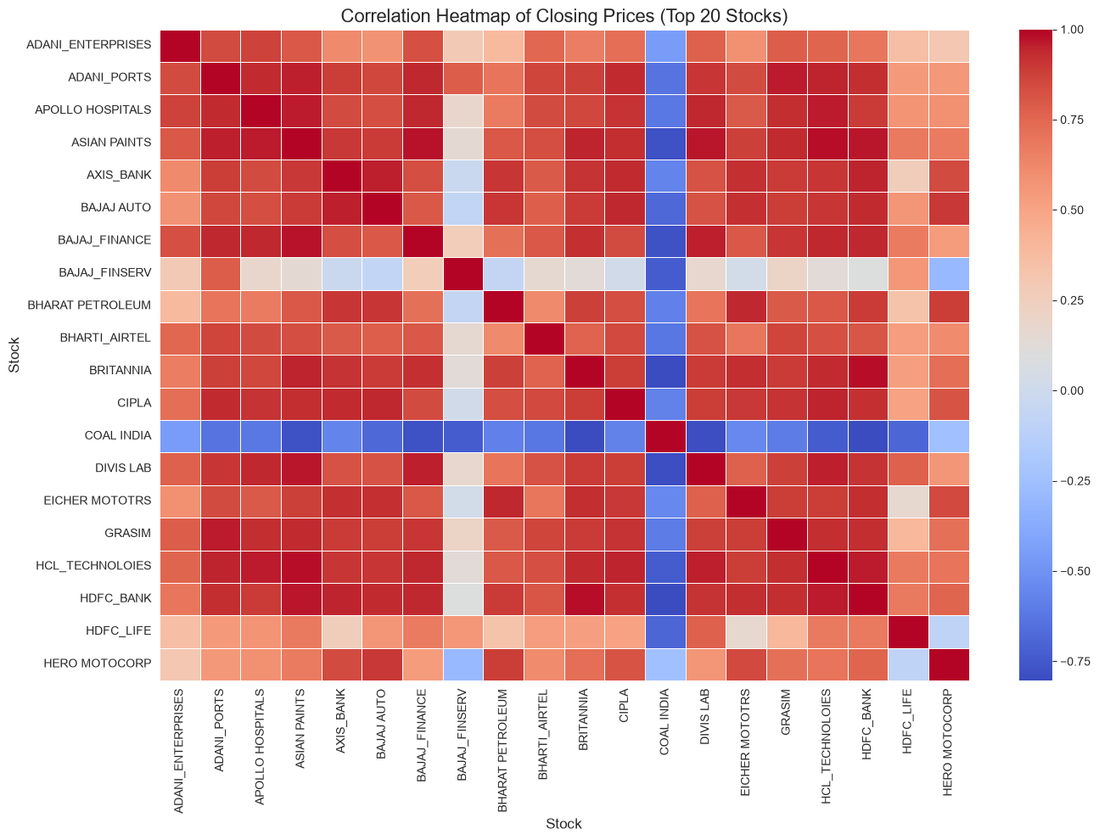
Figure 7: Heatmap illustrating the correlation matrix of closing prices for the top 20 stocks.
- Insights:
- Widespread Positive Correlation: The heatmap reveals a predominantly warm (red/orange) color spectrum across most of the matrix. This indicates a strong widespread positive correlation among the majority of the top 20 stocks, meaning their closing prices tend to move in the same direction, largely driven by overall broader market trends.

- The "COAL INDIA" Anomaly: The most striking feature of the heatmap is the dark blue band corresponding to COAL INDIA. This signifies a strong negative correlation with almost all other stocks in the top 20 list. When the broader market (represented by other stocks) moves up, COAL INDIA's closing price often moves down, and vice versa.
- High Intra-Sector Correlation (Example): Stocks like BAJAJ_FINANCE and BAJAJ_FINSERV show deep red squares when mapped against each other, indicating an extremely high positive correlation, which is expected for companies within the same financial group/sector.
- Recommendations:
- Portfolio Diversification (Hedging): COAL INDIA presents a unique opportunity for portfolio diversification. Because it moves inversely to the majority of the top 20 stocks, including it in a portfolio can act as a strategic hedge to stabilize overall portfolio volatility during broader market downturns.
- Avoid Over-Concentration Risk: Investors should be cautious about heavily weighting their portfolios with highly correlated stocks (e.g., holding both BAJAJ_FINANCE and BAJAJ_FINSERV). While this maximizes gains during upswings, it also exponentially increases risk and potential losses during sectoral downturns.

- Perform backtesting of the top 20 Nifty 50 stocks using the moving average crossover strategy and evaluate their performance based on key metrics such as total returns, annualized returns, maximum drawdown, Sharpe ratio, win/loss ratio, and number of trades executed.
Answer:
- Guideline: Evaluate the effectiveness of the 20-day vs. 50-day Moving Average (MA) crossover strategy applied historically across the top 20 stocks to determine its viability as a trading system.
- Insights:
- Total Returns & Annualized Returns: The backtesting reveals highly divergent outcomes. Stocks with strong, sustained historical uptrends (like ADANI_ENTERPRISES) generated substantial positive total and annualized returns using this strategy. However, stocks stuck in long consolidation phases (choppy markets) yielded flat or negative returns, as the strategy triggered "whipsaws" (false signals).
- Maximum Drawdown: The moving average strategy did not entirely protect capital from severe market crashes (e.g., 2008). While it signaled 'Sell' during extended downtrends, the inherent lag of a 50-day moving average meant initial steep drops were often absorbed before the signal triggered, resulting in significant historical drawdowns for highly volatile stocks.
- Sharpe Ratio (Risk-Adjusted Performance): Only a subset of stocks managed to maintain a strong (positive) average Sharpe Ratio. This indicates that for many stocks, the strategy's returns did not adequately compensate for the volatility (risk) endured.
- Win/Loss Ratio & Trade Frequency: The win/loss ratio for most stocks hovered near or below 1.0. This is typical for trend-following strategies, where a few large winning trades offset numerous small losing trades. The average number of trades (roughly 4 to 15 per year depending on the stock) confirms this is a medium-term swing trading approach rather than high-frequency trading.

- Recommendations:
- Selective Application: Do not apply this moving average strategy blindly across all Nifty 50 stocks. It should be exclusively deployed on stocks demonstrating strong historical trending behaviors (both upward and downward) rather than mean-reverting or sideways stocks.
- Strategy Enhancement Needed: Given the deep maximum drawdowns observed, relying solely on a 20/50 SMA crossover is insufficient for strict risk management. It is highly recommended to introduce a supplementary filter—such as a trailing stop-loss mechanism or an absolute stop-loss percentage—to exit trades earlier during sudden market shocks, thereby improving the Sharpe Ratio and preserving capital.

- Based on the performance metrics, which stocks would be recommended for investment?
Answer:
- Guideline: Synthesize the overall backtesting results and key performance indicators to identify and recommend the most robust stocks for a balanced investment portfolio.

- Insights:
- Holistic Evaluation: The analysis confirms that relying solely on a single metric is flawed. For instance, while ADANI_ENTERPRISES yielded the highest total return, it also carried significant volatility. Conversely, NESTLE offered exceptional stability (lowest maximum drawdown) but lacked exponential growth.
- Risk-Adjusted Leaders: Stocks that consistently plotted in the top-right quadrant of the Sharpe Ratio vs. Total Return scatter plot (e.g., BAJAJ_FINANCE and ADANI_ENTERPRISES) demonstrated the optimal historical balance—generating high returns without disproportionate downside risk.

- Recommendations:
- For Aggressive Growth: Allocate a higher percentage of risk capital to stocks like ADANI_ENTERPRISES and BAJAJ_FINANCE. These assets have proven historical strength in compounding wealth and effectively capitalizing on moving average crossover trends.
- For Capital Preservation (Defensive Allocation): Include defensive stocks like NESTLE. Their exceptionally low maximum drawdowns provide a critical cushion to the portfolio, protecting capital during severe market crashes.
- Blended Portfolio Strategy: The ultimate recommendation is not a single stock, but a carefully blended portfolio. Combining high-Sharpe-ratio growth stocks with low-drawdown defensive stocks—and potentially utilizing inversely correlated assets like COAL INDIA as a hedge—will create an optimized, resilient investment strategy.

